**Final Presentation**

**C++ Programming for Game Engines**

Vlad Adrian Dumitriu

S16102144

Contents

Introduction………………………………………………………..…….……3

Implementation……………………………………………….………………3

Minimax Algorithm…………………………………………………………..5

User Guide……………………………………………………………………6

Features Accomplished……………………………………………………….8

Introduction

The main idea was a game based on the classic Tic Tac Toe which is a game where just two players, *X* and *O*, who take turns marking the spaces in a 3×3 grid. The player who succeeds in placing three of their marks in a horizontal, vertical, or diagonal row wins the game. The game had to be implemented in C++ language.

Implementation

Libraries used:

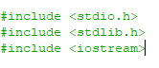

Functions:

1.Grid drawing function:

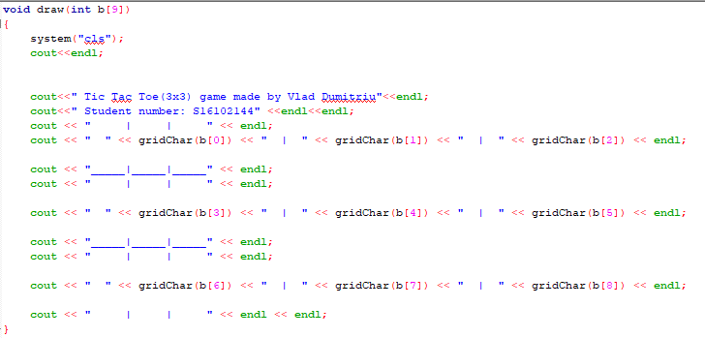

2.Function for player’s move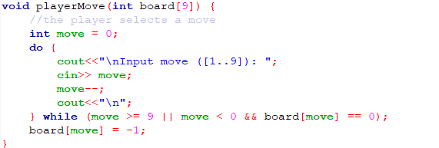

3.Function for computer’s move

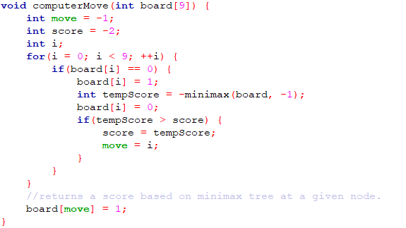

4.Win-check function

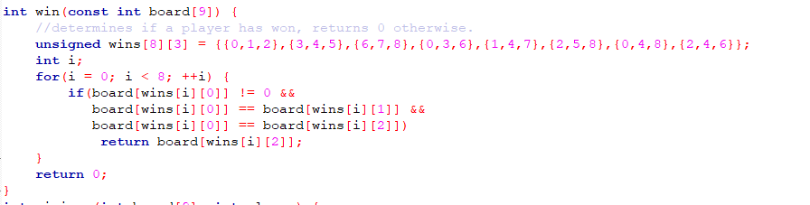

5.Minimax algorithm for the computer’s move

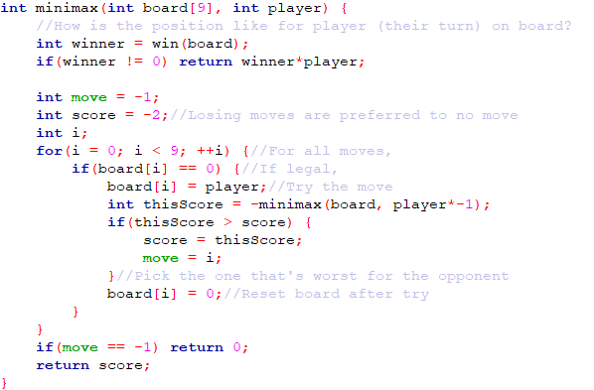

Minimax Algorithm

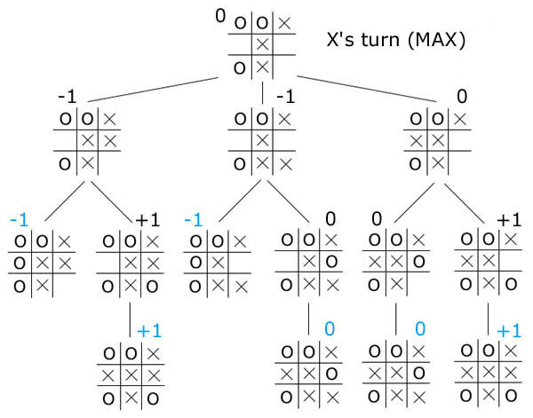

The idea is based on the enemy’s turn because after that one is calculating all the possible outcomes from that certain state. For example in this image, the first branch is for the first possible move for the “X” ( computer being “O”) , where “-1” for computer is a win, “0” is a draw and “+1” win for the enemy. After the first move, the minimax algorithm is running again on the second branch based on the second enemy move and so on until the game is done.

User guide

The game is on the console based. When is it running the first massage will be:

At this stage, the player is asked if he wants to play versus another player or versus computer. The answer is based on the number introduced on the console , followed by the “Enter” key.

Let’s presume that we choose the 2’nd answer. The next message will asked the player if he wants to start first or second and it informs him that he is always be with the symbol “X”



After that, the game starts itself with the 3x3 grid, above with the person who made the game and below an information that tells to the players to put a move between 1 and 9.

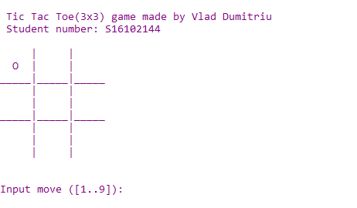

That move is consecutive on the board:

1 – 2 – 3

4 – 5 – 6

7 – 8 – 9

And the move should be selected like on this image: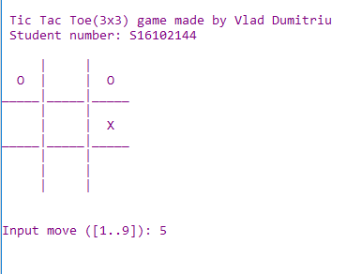

Where the player wants to put the move 5 , which should be in the middle of the screen and instantly the computer based on the minimax algorithm should select the move “2” to have 3 “O” in a row and win the game,

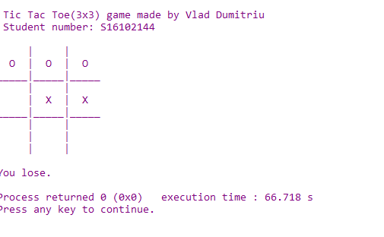

Features accomplished

-Changed the color for the font and text to have more graphics behind the console-based

-Made a game fully functional of tic tac toe

-Choose between player vs. computer and 2 players

-Make the computer to think it’s move, not just random

-Drawing the table every time the game starts

-Checks the win at every move and informs the player when the game is finished and the result as well.